**Experiment-3**

List out the entities and identify the relationship between them. Also, identify related attributes supposed to be recorded while considering the normalization rule.

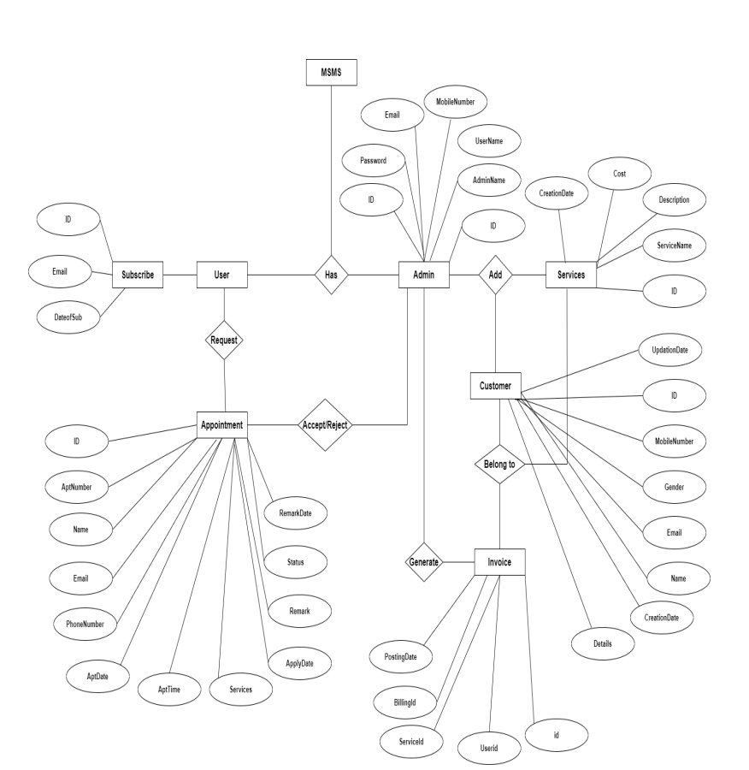

**Entities:**

* Customer: Name, contact information, service preferences, appointment history, loyalty status
* Employee: Name, contact information, job title, schedule, availability
* Service: Name, description, duration, price
* Appointment: Date, time, customer, employee, service
* Inventory: Product or service, quantity, reorder point
* Sale: Date, customer, employee, service, price

**Relationships:**

* One customer can have many appointments.
* One employee can have many appointments.
* One service can be included in many appointments.
* One appointment can only have one customer, one employee, and one service.
* One inventory item can be used in many sales.
* One sale can only include one inventory item.

**Related Attributes:**

* Customer: Name, contact information, service preferences, appointment history, loyalty status
* Employee: Name, contact information, job title, schedule, availability
* Service: Name, description, duration, price, inventory item(s) required
* Appointment: Date, time, customer, employee, service, price, status
* Inventory: Product or service name, quantity, reorder point, cost, supplier
* Sale: Date, customer, employee, service, price, discount, tax